Dynamic Brake Light
Team Light Brakers
Team 21
Lecture WF 3:35p
Rowan McCune, Jacob Nguyen, Roman Tagliola, Mitchell Vallis
“Emails”

Abstract:
Our project is a dynamic break light that increases in brightness the more you are applying the break. This would be most beneficial in cars, to indicate to the person behind the vehicle how much the person in pressing on the breaks. This could lead to decreased car accidents as people would now be aware when the driver ahead of them is slamming on the breaks. We will be implementing this idea and design on a bicycle.

Project Scope:
Plan A:
Our dynamic break light will increase brightness the harder the user is pressing on the brakes. A lollipop shaped device will be attached to the exterior of the handlebars. The stick portion of the lollipop will face forward and will be a channel with a spring inside. The brake handle will fit into the channel. As the break is pulled, the spring will compress, pushing down on a pressure plate at the base of the spring. The more force applied to the pressure plate, the brighter the break light will light up.
Our goal is to create an original, functioning device. The design of the project will allow us to gain experience in coding, 3D printing, design, installation, and troubleshooting. Project success means the light increases in brightness as we increase pressure on the brake handle.
The project will be split into three sections. Coding, 3D design and printing, and installation and troubleshooting. We will create and code the device ourselves. We will use the laser scanner to scan the handlebars of the bike and use those scans to create the attachment for the handlebars. We will buy the spring, wiring, an Arduino to program, and an LED for the brake light. Other miscellaneous pieces might be required as the project gets underway. The 3D printers and laser scanner within the ITLL will be useful and necessary for this project.
Plan B:
Due to the complexity of Plan A, we have come up with a Plan B that uses an accelerometer. We will use an accelerometer to measure acceleration. If there is negative acceleration, the brake light will light up. The greater the deceleration, the greater the brake light lights up.

Specifications:
Electrical:
Component | Minimum Performance | Maximum Performance | Advertised Performance
Arduino | 3 Months | 5 Years | 2-10 years
Batteries | 20 hours | 200 hours | 120 hours
Light | 5,000 hours | 50,000 hours | 25,000 hours
Pressure Sensor | 200 Hours | 300 Hours | NA
Accelerometer | 200 Hours | 500 Hours

Mechanical:
Component | Minimum Performance | Maximum Performance | Advertised Performance
Wiring | 1 Year | 5 Years | 5 Years
Handle Bar Attachment | 6 months | 2 Years
Spring | 1 Year | 3 Years
Mounting Brackets | 2 Years | 4 Years

Design Elements:
Mechanical:

Electrical:
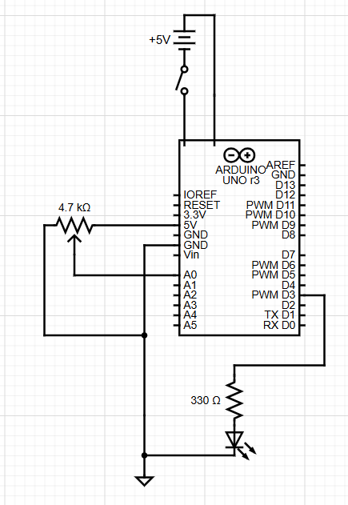

Bill of Materials:
Item: | Cost ($):
Arduino | $30
Filament for 3D printing | $10
LED | $10
Spring | $3
Wiring | $3
Batteries | $8
Battery Case | $5
On/off Switch | $3
Casing for Arduino | $25
Pressure Sensor | $13
Total: | $110

Risk Mitigation:
The biggest concern is the structural integrity of the Arduino, which we will program to control the LED. Exposure to the elements and vibrations from riding the bike could significantly shorten the life of the Arduino. The mitigate this, we will explore a shock and weather resistant casing.

Timeline:
9/30/25: All parts that need to be ordered are ordered
10/10/25: Designs for 3D printing finalized
10/17/25: Coding Finished
10/31/25: Troubleshooting and testing completed
11/9/25: Finished and installed on bike

Tools:
We will use 3D printers and laser scanners.

Conclusion:
Our plan is attempt Plan A, but due to the complexity and skill restraints, we will quickly shift to Plan B to make sure we have a fully functioning product by the date of the EXPO.

